Connect Table Rule and Graph

Learn points say which quantities go together
Write a point as (x, y): input first, output second. On these graphs, time is horizontal and total water is vertical. The origin is (0, 0). A proportional graph is a straight line through the origin over its allowed inputs. A straight line with a nonzero starting value is not proportional.
For 0 to 4 minutes, Empty start has y = 2 × x. Three liters at start has y = 2 × x + 3. Both gain 2 liters each minute, but their total-water relationships differ.
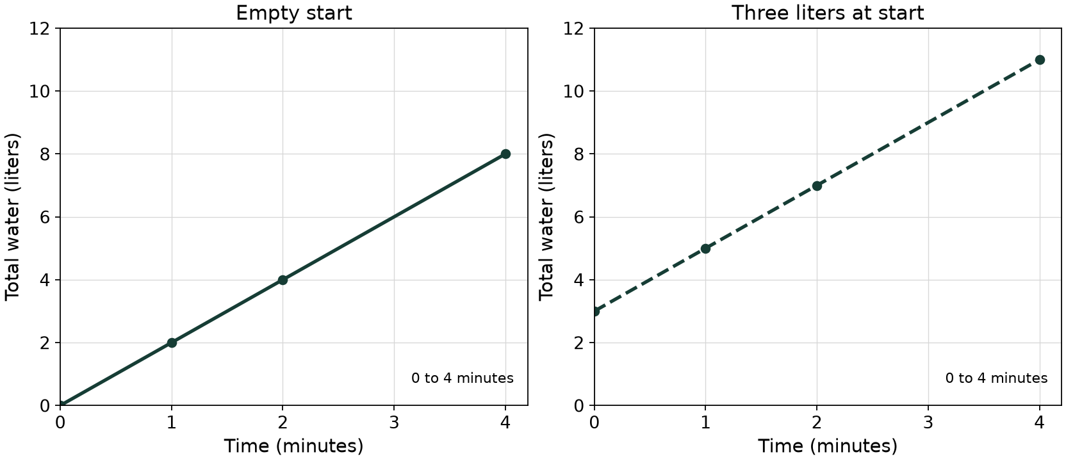
Time (minutes) | Empty start (liters) | Three liters at start (liters)
0 | 0 | 3
1 | 2 | 5
2 | 4 | 7
4 | 8 | 11
In the empty-start model, (1, 2) means 2 liters after 1 minute: k is 2 liters per minute. In the other model, (1, 5) includes the starting 3 liters. The output at one input unit is not its rate of increase.

Connect Table Rule and Graph

Guided practice a fractional constant
An empty tank gains 1.5 liters each minute, for 0 to 4 minutes. Let x be time in minutes and y be total water in liters.
x (minutes) | y (liters)
0
1
2
4
Complete the table. State k as a decimal or fraction with units and write a rule. On the supplied grid plot the four pairs; join them only within the stated continuous-time domain. Explain (0, 0) and the point at one minute.
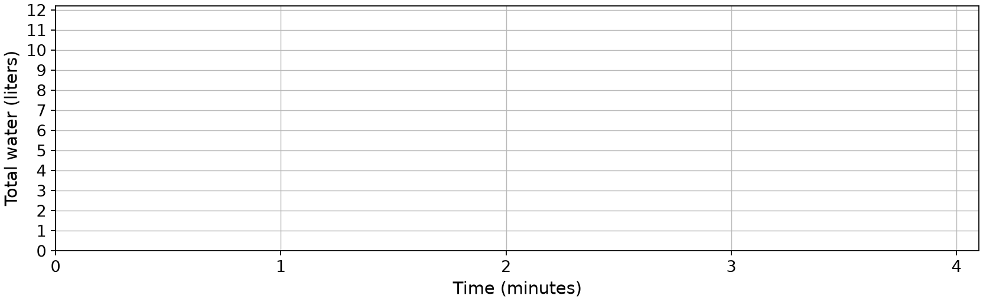
Rule, units and point meaning

Connect Table Rule and Graph

Practice check a straightline shortcut
For 0 to 4 minutes, a different tank begins with 2 liters and gains 2 liters each minute.
Time (minutes) | Total water (liters)
0 | 2
1 | 4
2 | 6
4 | 10
Fictional learner Ari says, “The graph is straight and passes through (1, 4), so total water is proportional to time with k = 4 liters per minute.” Plot or describe the given pairs. Decide whether the claim and proposed rule y = 4 × x fit. Give a rule matching the stated model and explain the starting point.
Evidence, rule and point explanation

