Reteach: Observe Before You Infer

Use a precise observation
Point to a printed feature first. Useful stems: “This map labels …”; “Next to … I see …”. A statement about why or when a physical change happened usually needs more than one observation.
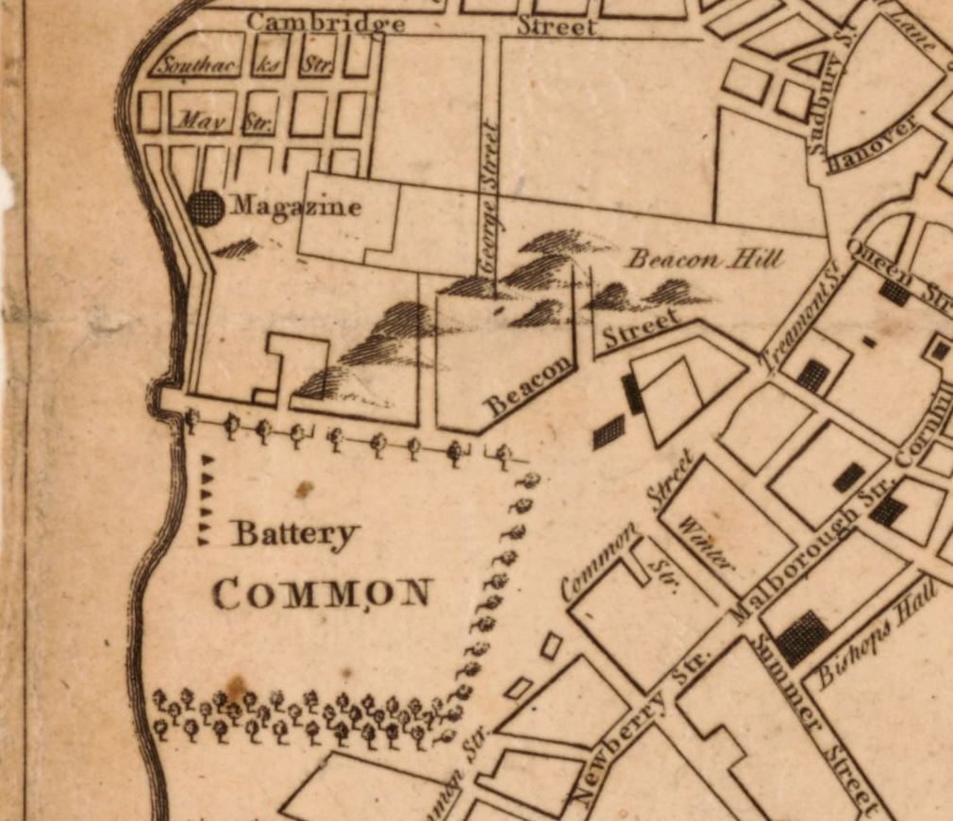
A new and correct plan of the town of Boston. Published in London in 1775 (October, according to the catalog); creator unnamed in the catalog. Library of Congress, Geography and Map Division. Detail from the original map. Source: https://www.loc.gov/item/2018590109/

Reteach: earlier evidence
Finish “This map shows …” with a label and its relationship to COMMON. Underline the words that tell where you looked.
Your response

Reteach: Observe Before You Infer

Connect observations without overclaiming
Use this detail with the preceding one. Locate the Common and Beacon Street in each. Compare near these anchors, while allowing for the wider coverage of the later detail.
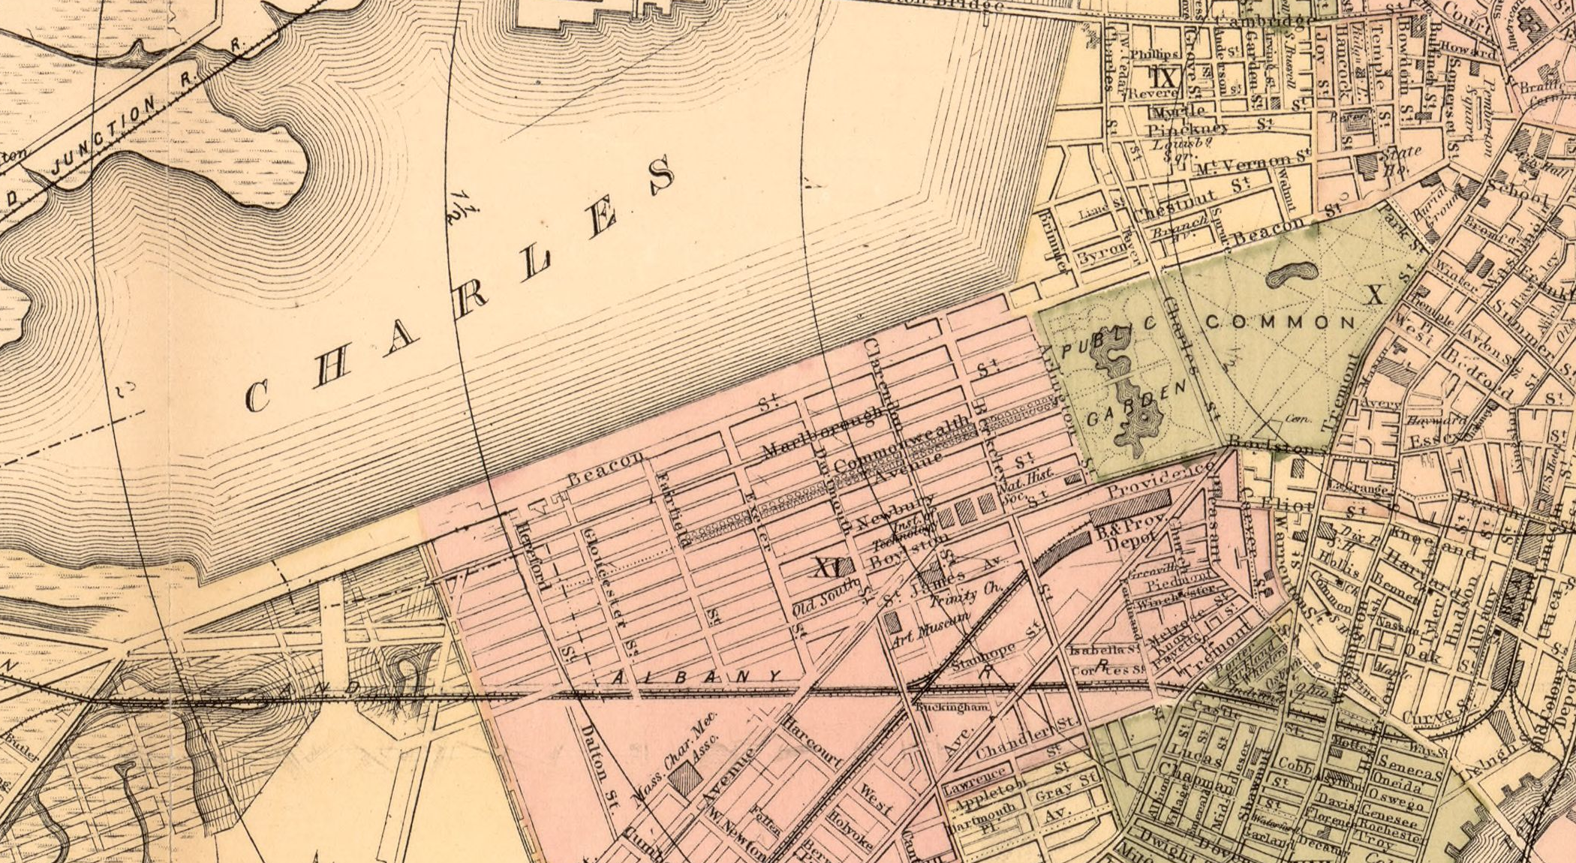
Map of Boston for 1883. Sampson, Davenport & Co., Boston, 1883. The print also has a separate 1882 copyright-entry date. Library of Congress, Geography and Map Division. Detail from the original map. Source: https://www.loc.gov/item/76692216/

Reteach: observation and inference
Write one observation from this map. Then write an inference about a difference near the Common using that observation and your earlier-map observation. Finish “This does not tell me …” with a specific limit.
Your response

