Lessons and Practice: Boston Maps and a Back Bay Report

Lesson 1: Read the earlier detail
A historical map is a selected representation of a place. Its maker chose what to label and draw. Start with things you can point to; explain changes only after comparing evidence. The Common is our named anchor, a feature that helps locate a comparable area.
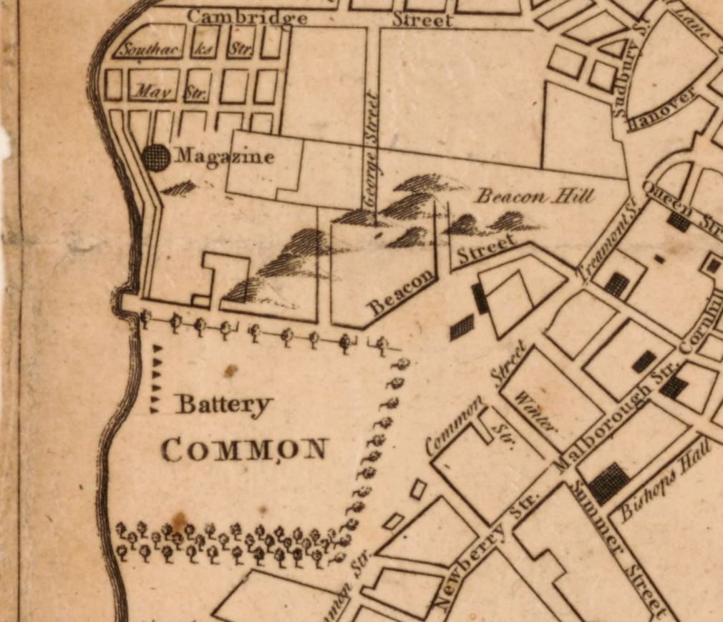
A new and correct plan of the town of Boston. Published in London in 1775 (October, according to the catalog); creator unnamed in the catalog. Library of Congress, Geography and Map Division. Detail from the original map. Source: https://www.loc.gov/item/2018590109/

Earlier-map observation
Locate COMMON and Beacon Street. Describe one visible feature next to the Common, using a label or a line pattern. Say what the map shows, without giving a cause.
Your response

Lessons and Practice: Boston Maps and a Back Bay Report

Lesson 1: Read the later detail
Find PUBLIC COMMON and Beacon St. The later original covers a much wider area than the earlier original. These details have been chosen around shared landmarks; their printed sizes do not mean equal distance or area.
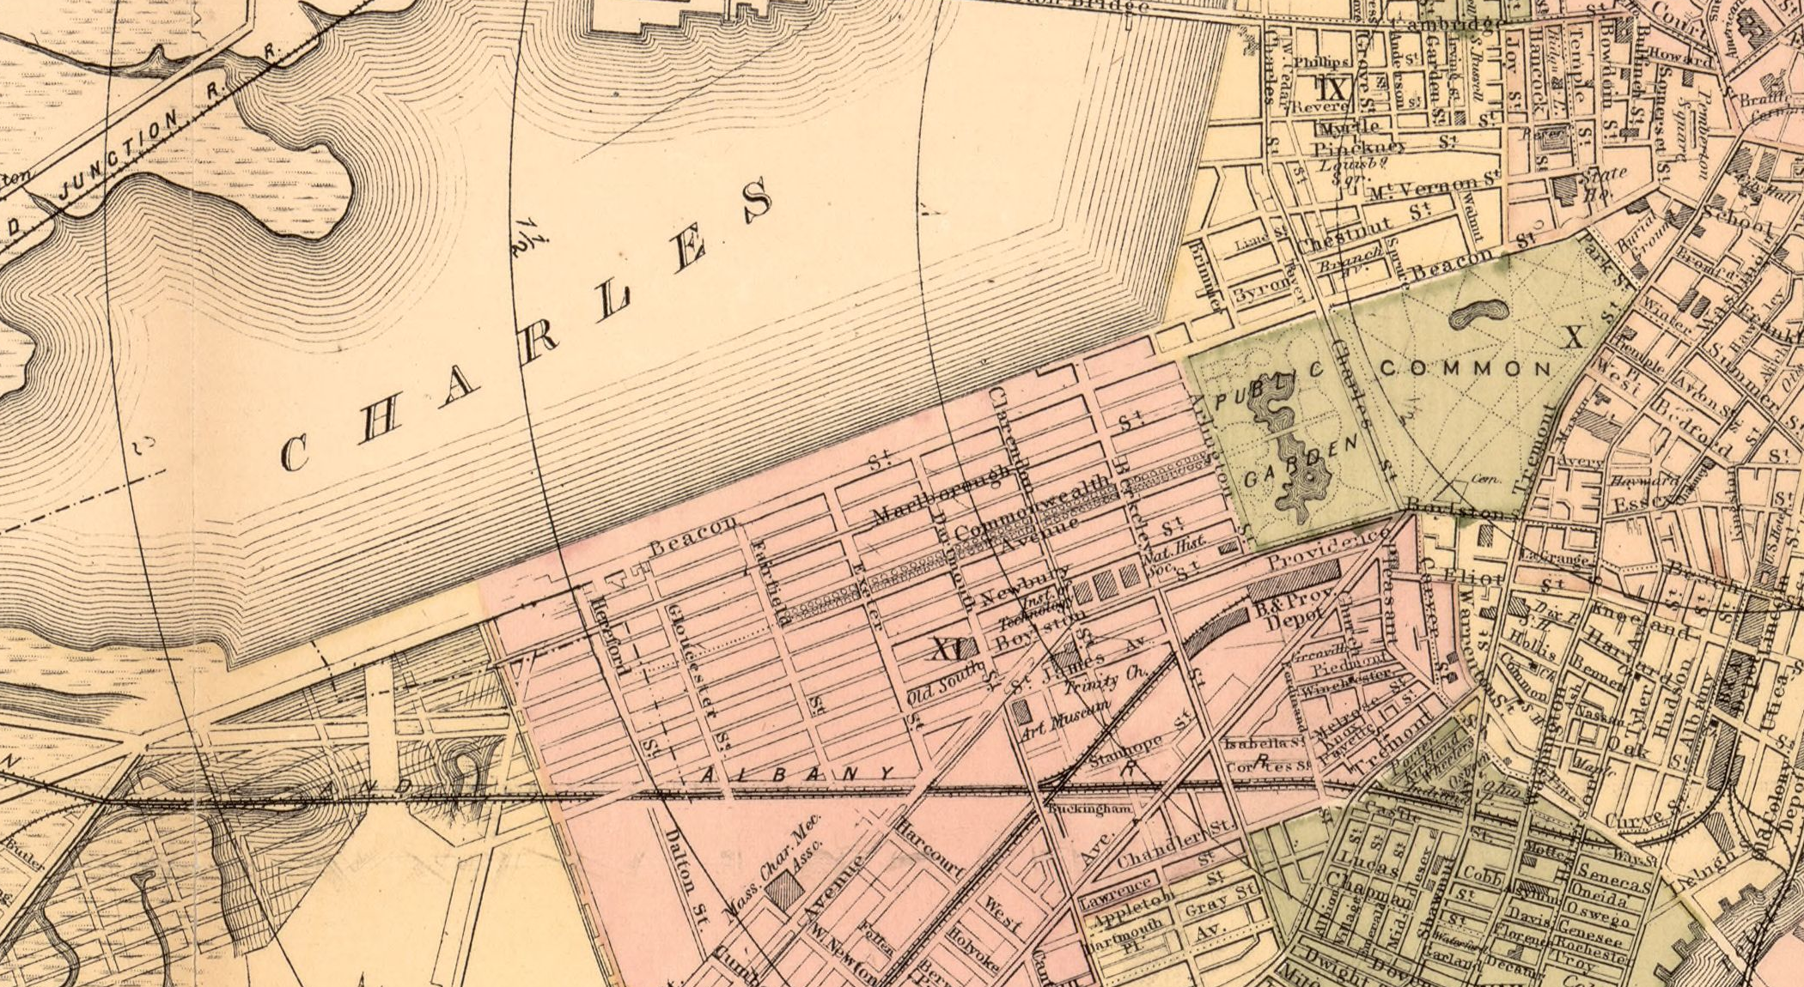
Map of Boston for 1883. Sampson, Davenport & Co., Boston, 1883. The print also has a separate 1882 copyright-entry date. Library of Congress, Geography and Map Division. Detail from the original map. Source: https://www.loc.gov/item/76692216/

Later-map observation
Locate PUBLIC COMMON and Beacon St. Describe one visible feature on the side toward the Charles River, using a label or line pattern. Keep your statement about this map.
Your response

Lessons and Practice: Boston Maps and a Back Bay Report

Lesson 1: Compare a location fairly

A small worked model
Observation: the earlier detail labels COMMON; the later detail labels PUBLIC COMMON. Inference: these shared names, together with Beacon Street in both details, help us compare the same vicinity. Limit: the labels alone cannot prove every boundary stayed in exactly the same place.
For this comparison, the Common and Beacon Street locate the general area. The earlier original has a shoreline boundary immediately to the west of the Common; the later detail includes a wider area toward the Charles River. Compare the pattern near the anchors. Do not align the page edges or count the whole later crop as a matched area.

Compare the Common area
Use the two preceding details. Identify the shared anchors. Give one observation from each map and explain a supported difference in the depicted land, water boundary or streets near the Common. Add one reason the comparison cannot give an exact amount of physical change.
Your response

Lessons and Practice: Boston Maps and a Back Bay Report

Lesson 2: A report has its own date and purpose
1861 House Bill 0062. Report Of The Committee On Public Lands Regarding Back Bay Lands. Massachusetts House of Representatives, Committee on Public Lands; February 7, 1861. First report page. State Library of Massachusetts. Source: https://archives.lib.state.ma.us/handle/2452/725940

Short excerpt
“N. C. Munson, the contractor for filling the Back Bay, in payment for work done prior to that date”

Meaning in present-day language
A Massachusetts legislative committee reported that, in 1860, land was transferred to N. C. Munson as payment for work he had already done filling the Back Bay. This records a contractor and payment for filling work. It does not tell us that all the filling was finished then.
The committee was investigating public land disposal and payment. We have a short passage from its report, not testimony from all residents or workers. Use the passage for what it says about this work.

Put the evidence in time
Write a short timeline with the earlier map publication, the year of work/payment described in the report, the report date, and the later map publication. Explain why 1861 is not the same kind of date as 1860 here.
Your response

Lessons and Practice: Boston Maps and a Back Bay Report

Lesson 2: Build a limited explanation
Use the two Common-area details and the report passage supplied in this packet. Observation names what a map shows or a report says. An inference connects those details to a claim. A limit says what the evidence leaves open.

Explain with three sources
Write an explanation of the changed pattern near the Common toward Back Bay. Include a detail from each map, what the report adds, and one limit on your explanation. Use source names or dates so a reader can follow your evidence.
Your response

Test a stronger claim
A caption says, “The 1861 report proves the whole Back Bay was finished that year and everyone benefited.” Explain which parts the supplied passage supports and which parts need other evidence.
Your response

