Independent Check: Mill Pond Area

Read the earlier Mill Pond detail
Work with the evidence in this packet. Read the source cards and map details before explaining a change. Locate Mill Pond and the Prince/Salem/Hanover street network to its right.
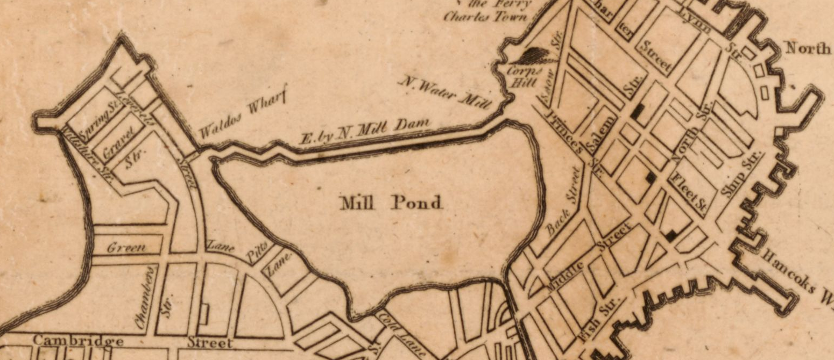
A new and correct plan of the town of Boston. Published in London in 1775 (October, according to the catalog); creator unnamed in the catalog. Library of Congress, Geography and Map Division. Detail from the original map. Source: https://www.loc.gov/item/2018590109/

Mill Pond: earlier observation
Describe the labeled area Mill Pond and one neighboring labeled street or boundary. Keep observation separate from explanation.
Your response

Independent Check: Mill Pond Area

Read the later northern detail
Use Prince, Salem and Hanover to find the same general street vicinity. Then look toward Causeway, Beverly and Merrimac on their left. This location guide identifies a general vicinity, not an exact overlay of the maps.
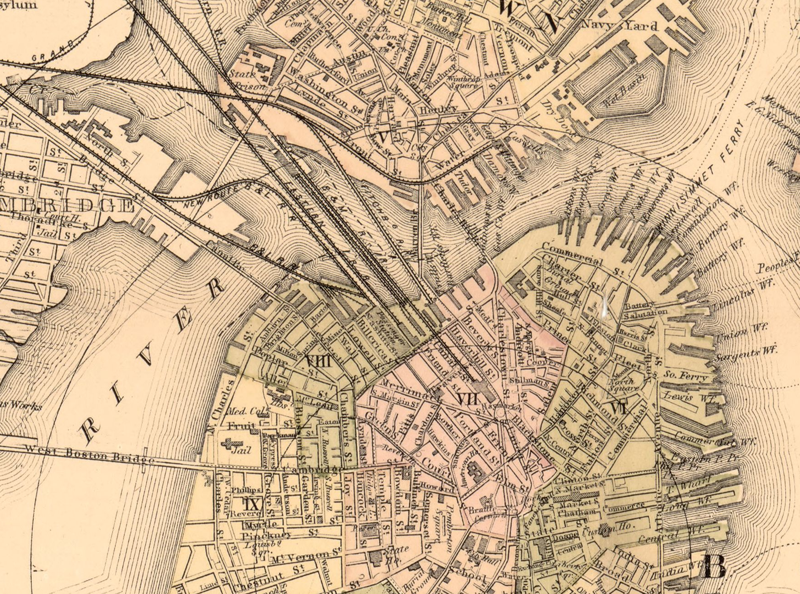
Map of Boston for 1883. Sampson, Davenport & Co., Boston, 1883. The print also has a separate 1882 copyright-entry date. Library of Congress, Geography and Map Division. Detail from the original map. Source: https://www.loc.gov/item/76692216/

Mill Pond: later observation
Name two visible features in or beside the Causeway/Beverly/Merrimac area. State what kinds of features they are, using the printed map evidence.
Your response

Independent Check: Mill Pond Area

Compare and limit the conclusion

Mill Pond: compare the pattern
Using the supplied location guide, give one detail from each map that supports a difference in the depicted pattern in the Mill Pond vicinity. Explain the difference as an inference. Name a reason to be cautious about an exact physical comparison.
Your response

Mill Pond: choose relevant evidence
Could the Back Bay report passage from the lessons establish the cause or completion date of the Mill Pond change? Explain using the named place and the limits of that passage.
Your response

