Follow-up Check: South of Essex Street

Read the earlier southern detail
Locate Essex Street near the northern edge of this detail. The map then shows a strip extending south toward Boston Neck. Use labels and boundary lines to describe it.
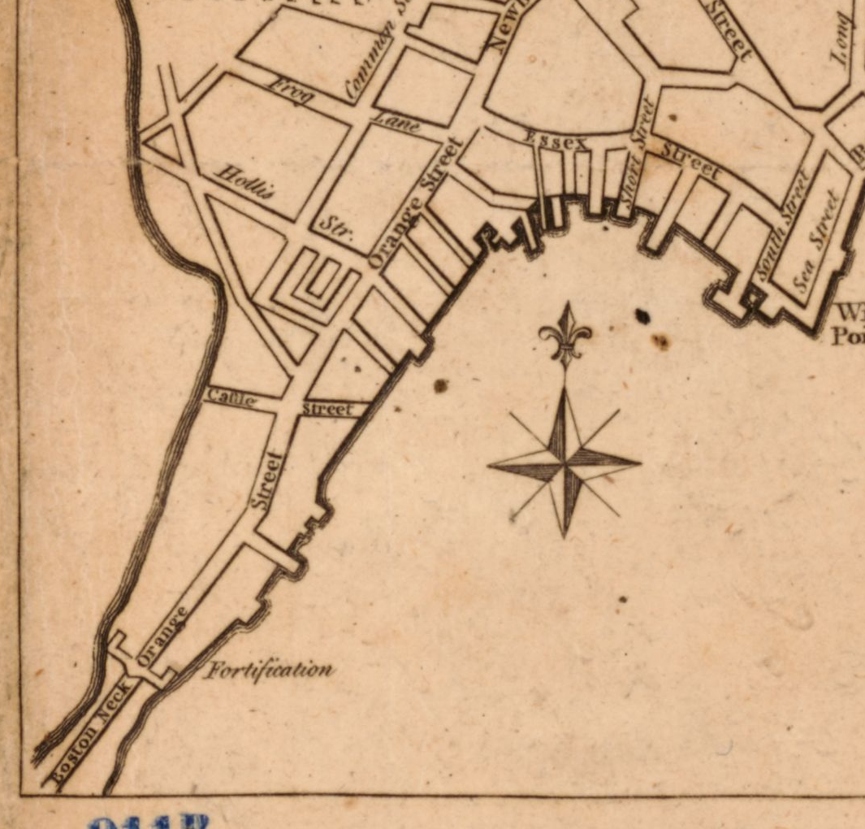
A new and correct plan of the town of Boston. Published in London in 1775 (October, according to the catalog); creator unnamed in the catalog. Library of Congress, Geography and Map Division. Detail from the original map. Source: https://www.loc.gov/item/2018590109/

Essex: earlier observation
Describe a visible feature south of Essex Street and its relationship to the strip shown on this map. Use a printed label and a boundary or street detail.
Your response

Follow-up Check: South of Essex Street

Read the later southern detail
Start at Essex Street. Look south toward the street blocks, rail/depot features and shoreline in this detail. Essex is the shared northern anchor. The location guide matches the general vicinity; it does not align every old and later street.
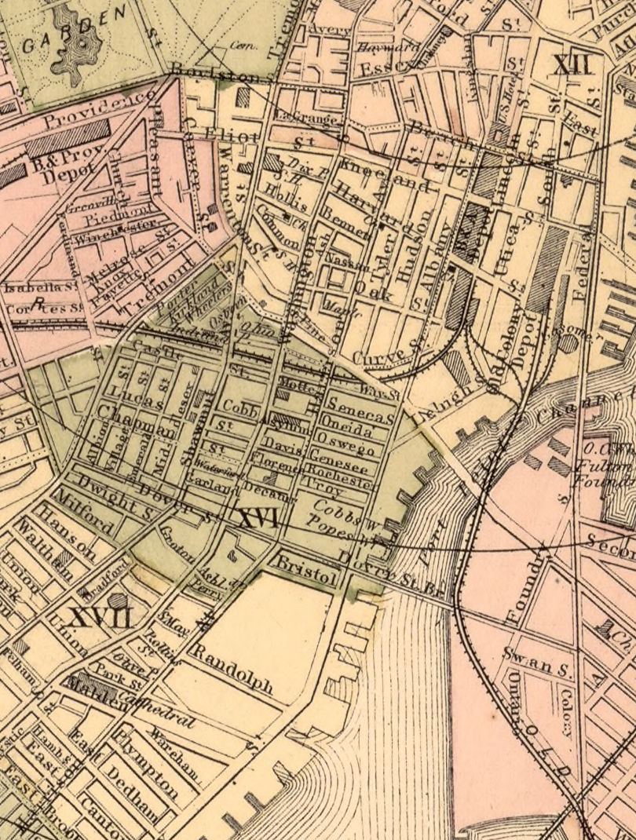
Map of Boston for 1883. Sampson, Davenport & Co., Boston, 1883. The print also has a separate 1882 copyright-entry date. Library of Congress, Geography and Map Division. Detail from the original map. Source: https://www.loc.gov/item/76692216/

Essex: later observation
Describe two visible features south of Essex Street using their labels or drawn patterns. Keep the description about this map.
Your response

Follow-up Check: South of Essex Street

Explain a new comparison

Essex: compare and qualify
Use Essex Street and the location guide to compare the two details. Give an observation from each and an inference about the depicted pattern south of Essex. Add a limit involving coverage, location matching or scale.
Your response

Essex: test the explanation
A reader says, “Orange Street must be Washington Street, and the Back Bay report explains all the changes in this detail.” Explain why those two claims need more evidence.
Your response

